Certificate of Authenticity Limited Edition Fine Art Print-Metal /Aluminum
Title “I am the other: through your eyes, I see myself” 2019
Original Media Digital Photography/mixed media
Original Image Size DPC (digital photographic capture)
Original Creation Date 2018-19

Artist's Name Nancy Bechtol

Artist Signature ___________________

Print Limited Edition 3 of 5 (AP)
Print Image Size 16” x 20”
Proof(s) Held By Artist 3
Proof(s) Held By Printer 1
Printing File Status Retained by Artist
Notes “Fashioning the Self: You are What you Wear?”
Koehnline Museum Oakton CC/WGS Women’s Gender Studies Exhibition 2019.
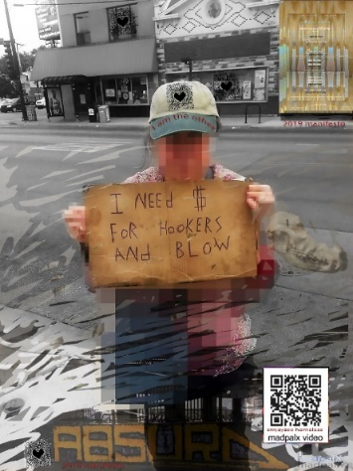
Medium: Photography _metal print/montage/digipainting/writing on edges of frame/ with QR code 18” X 24” framed
Charged with the impact of the moment. The realization that we are all the “other” The way we look or think of ourselves may not be what others see in us. You are what you wear. Yes. you wear your clothes and you wear your skin, you wear your thoughts, words and deeds.
The clothing is the outward sign. An action.
This image transformed me. A thought-provoking moment when I found a street sign discarded. It was well used-gritty, grimy, honest and even humorous. I was alarmed then compelled to hold it. I am the other. Bonded, in solidarity.
Within the moment, seeing through the eyes of the other person. Yes. The prior bearer of the sign heralds the increasing number of people wandering, and in tent cities citywide, the abandoned in the era of Trumpian deceit and evil doers. Let US be empowered. Unite In solidarity, In truth. I add my voice and continue to witness/document/Speak TRUTH to power. Art is Speech.
QR Code links to video on YouTube I made of Emjayee. RIP. Poet, Vietnam Vet, homeless living on a golf course.
https://youtu.be/Q5jUvc4VyNg You are noticed or you are passed by, you are discarded or have a seat at the table, you are praised, you are honored, you are branded or you are anonymous. Clothing is optional, can be changed and discarded, but signal to the others of what tribe you profess to be with. Clothing and ornamentation or lack of is a powerful thing.
Nancy Bechtol is an artist, photographer, director/indie filmmaker, educator, and media specialist/consultant. Photojournalist, APA. Member Chicago Society of Artists, ARC Gallery Affiliate, Lost Artists Colony guest artist, Chicago's CAN TV indie producer. Studied painting with the legendary Don Baum, Chicago Imagists. Influenced by the Hairy Who with BA from Roosevelt Univ and at Loyola Univ of Chicago MA Ed, Interdisciplinary arts III, and evolved as a techno-fetisher in the early 80s MFA/SAIC mentored by Phil Morton, founder of Video Dept The School of the Art Institute of Chicago. She always collects experiences. AWARDS::Midwest Regional Fellow National Endowment for the Arts Illinois Arts Council Fellowship Award-Media Arts Neighborhood Arts Program Artist at Lathrop Homes, Chicago Housing AuthorityCHA City of Chicago. Dept. of Cultural Affairs American Video Conference Award sponsored by the American Film Institute Billboard Magazine Tokyo International Video Festival, Special Merit Award in Experimental Video Art, American Registry of Outstanding Professionals, Chicago Access Network Television (CAN TV) Independent Producer 1986-current. http://www.absolutearts.com/nancybechtol http://artslant.com/global/artists/show/32212-nancy-bechtol http://bit.ly/NancyBechtolARC

